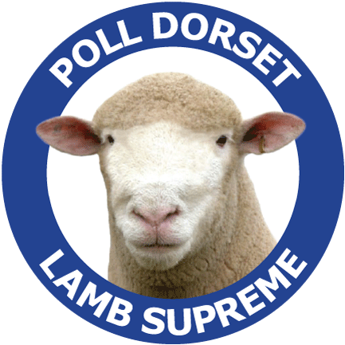
Contact Details Date: March 27, 2020
THE AUSTRALIAN
POLL DORSET
JOURNAL
Advertising Confirmation

Company Name:
Contact Person:
Billing Address:
City: |  |  | State: Postcode:
Contact Number: |  |  |  |  |  |  | Email:

*Book 3 consecutive issues and receive a 5% discount of total cost

*New advertisers receive a 30% discount off one add OR buy 3 and get the third ad FREE

*To qualify has not advertised in the past 5 years
Advertising Rates |  | member |  | Commercial |  |  |  | Details:  Repeat Advert ☐ Yes/No ☐ If Yes which issue?  ¼ page (v☐) (H☐) Artwork Supplied: Yes ☐ No /Partly ☐  Format supplied: Yes ☐ No /Partly ☐  Advertising Size:  Full page ☐ Double page spread ☐  Half page (v☐) (H☐) 1/4 page ☐
Back Cover |  | $751 |  | $938
Inside front and back cover |  | $601 |  | $751
Double page spread |  | $889 |  | $1112
Centre spread |  | $947 |  | $1184
Full page |  | $543 |  | $679
Half page |  | $358 |  | $448
Quarter page |  | $219 |  | $274
1/8th page |  | $162 |  | $202
Issue Print Date  May ☐  Rate: $  September ☐  Rate: $  December ☐  Rate: $ |  |  |  |  |  | Payments  ☐ Cheque/Money order (please cross out not applicable)  Please make cheques out to Australian Poll Dorset Association  ☐ Electronic ☐ Funds Transfer  If paying by electronic transfer, please  fax confirmation to: (03) 54439354  Banking Details: National Australian Bank  Account Name: Australian Poll Dorset Association  BSB: 0850-005  A/C Number: 02663 5370

Advertising bookings and enquiries:

Patrick Falconer

Unit 1/6 Merino Court East Bendigo Vic 3550

Phone: (03) 5443 9902

Fax: (03) 5443 9354

Mobile: 0409 013 608

Email: marketing@polldorset.org.au

Finished artwork to be forwarded to the sam@polldorset.org.au

Booking Deadlines
Issue | Advertising Booking |  |  |  | Advertising material |  |  |  | Date posted
May | April 7th |  |  |  | April 14th |  |  |  | April 28th
September | August 6th |  |  |  | August 8th |  |  |  | August 23rd
December | November 6th |  |  |  | November 13th |  |  |  | November 27th
Advertising Specifications  All pricing includes full colour adverts which are GST inclusive  Please note (SERVICE FEE) applies where artwork is not supplied for basic typesetting/layout fee will apply.  Service fees do not apply where the complete advertising copy layout is supplied as a high resolution CMYK PDF file.  Print ready advertisements must be supplied as CMYK (not RGB) PDF  Full page adverts need a 3mm bleed and crop marks  Supplied photographs: When sending photographs electronically for advertising or editorial use, they need to be at least 1MB in file size and high resolution; and attached as a jpeg file.  Word, Publisher, PowerPoint and other file formats cannot be used for full production but may be supplied as a layout guide – however, photos must be supplied separately. |  |  |  | Service Fees  Full page  $104.50  1/2 page  $82.50  1/4 Page  $60.50  1/8 Page  $49.50
Advertising Specifications | Size | Member | Photographs supplied |  | Copy layout provided
Full page (full bleed) | 303mm deep x 216mm wide
Full page bordered | 270mm deep x 182mm wide
Double page spread | 303mm x 426mm wide
Half page (H) | 13mm Deep x 182mm wide
Half page (V) | 270mm deep x 88 mm wide
Quarter page (H) | 62mm high x 183mm wide
Quarter page (V) | 13mm deep x 88mm wide
One eighth page | 62mm high x 88mm wide
Up to 4 photographic scans are included in the service fee additional scans are $5 each

All advertising orders are to be received a full week prior to material closing dates below

